Paper Тitle

Name Family, Name Family, Name Family
Affiliation, City, Country
Abstract: The text should be between 10 and 15 lines long, has to be written as „Abstract“ format, Arial 11 pt, italic, single line spacing, justified. It should present the purpose and main aspects of the report.
Keywords: 3 to 5 keywords should be noted, „Keywords“ format, Arial 11 pt, italic, single line spacing, justified.

INTRODUCTION
Introduction should contain the following parts:
- Actuality of the topic
- Object of study
- Main purpose and task of the study

methods and aproaches
This part should present the applied methods and approaches in the study.

results and discussion

Text
Each paragraph in the same Heading has to be written as „Normal text“ format. These settings are Arial 11 pt, single line spacing, justified and the first line is indented 0.7 cm. Please do not format the text with italics, bold or underlined. Please do not use more than one space between two words.

Tables and Figures
The text in the Tables has to be written as „Table text“ format. These settings are Arial 10 pt, single line spacing and right-justified. Please do not format the text with italics, bold or underlined. The Table lettering is always above the Table and eventually Table explanations are below the Table. Please use the pattern Tab. 1 for building the Tables. Here is valid the „Table caption“ format, Arial 10 pt, single line spacing:

Tab. 1: The word „Table“ is abbreviated as „Tab.“.
Solar region ¹ | Direct, W/m² | Diffuse, W/m² | Total, W/m² | Daily, kWh/m²
Sofia | 510 | 210 | 720 | 5.45
Blagoevgrad | 600 | 200 | 800 | 6.21
Sandanski | 655 | 230 | 885 | 7.56
¹ In Bulgaria

Figures have to be written as „Figure caption“, Arial 10 pt, single line spacing. The Figures lettering is always below the respective Figure.

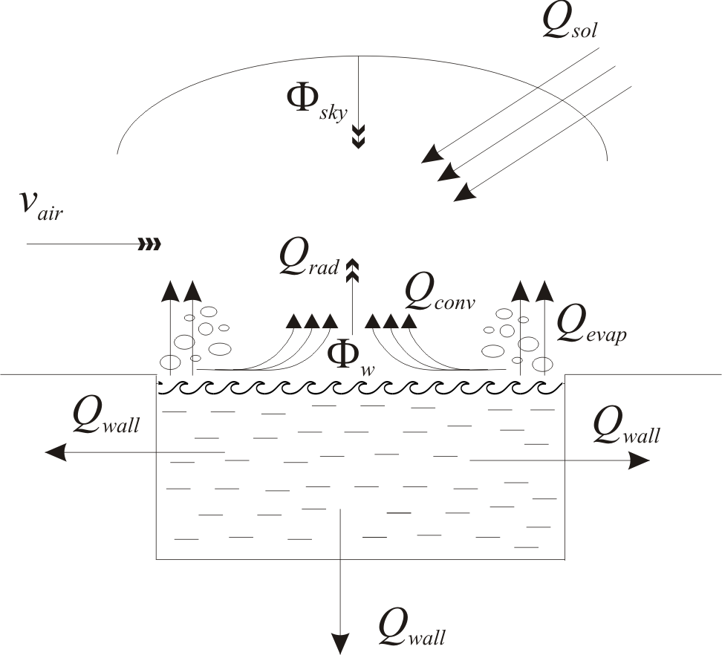

Fig. 1: The word „Figure“ is abbreviated as „Fig.“.

Figures and Photos must be included in their original sizes in one of the following graphic formats: pcx, eps, tif or jpg. The minimal resolution for Photographs should be 300 dpi, as well as 1200 dpi for Diagrams and Charts.
All Tables and Illustrations should be numbered consecutively in the order to which they are referred.

Equations
All equations must be written with the „Formula“ format, Arial size 12 pt, single line spacing. All equations should be numbered at the left side of the text line, and should be referred in the text according to this number. For example:
(1) $c=c_{1}\frac{K_{D}(Т_{w^{2}}−Т_{D})}{Z}$
Please use the international S.I. units:
- Mg, Kg, m, kJ, cm, etc.
- 9.000 instead of 9000

References
The referencing in the paper to literature sources should be indicated by figures in square brackets.

CONCLUSIONS
The Conclusions should present the brief outputs of the study.

references
References should be formatted with the „Reference“ style, Arial size 12 pt, single spacing. The rules for referencing Books and Journals are presented as follows:
- Last name, Initials (Year) Book Title. Publisher, City, Country.
- Last name, Initials (Year) Title of the Article. Title of Journal Volume number: Page numbers.

Examples:
- Wilcox, R. (2005) Introduction to Robust Estimation and Hypothesis Testing, Elsevier Academic Press, Amsterdam, Netherlands.
- Babanova, S., Hubenova, Y., Mitov, М. (2011) Influence of artificial mediators on yeast-based fuel cell performance. Journal of Bioscience and Bioengineering 112: 379 – 387.

All headings have to be written as „ Heading 1“ format, Arial 11 pt, single line spacing, 24 pt spacing before and 6 pt spacing after the capital letters.
Please, save your file with the following denomination „Family name, Paper title“ with maximum 40 characters long.
The recommended number of pages is 6-8 including figures and tables.
The prepared manuscript must be submitted to the e-mail: pmf@swu.bg within the deadline 30th November 2020. Later delivered papers will not be further reviewed!
Please note that, due to the uniform layout of the Proceedings, only the papers formatted according to this template can be accepted.

